USING TEXT ELEMENT

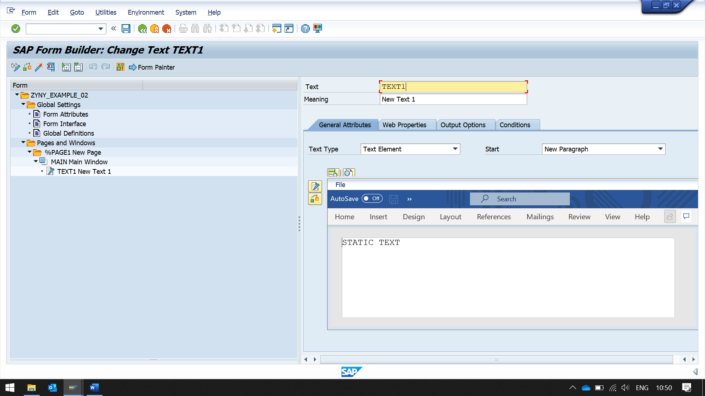

IN TEXT, ENTER THE TEXT TO BE PRINTED

NOW USING GLOBAL DEFINITIONS,

CREATING A VARIABLE

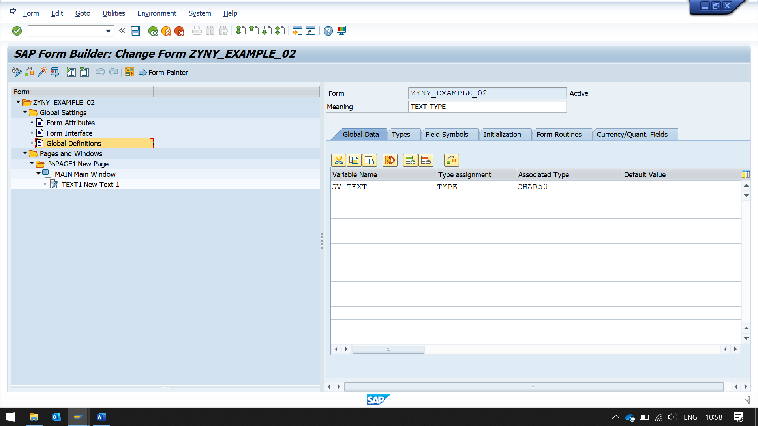 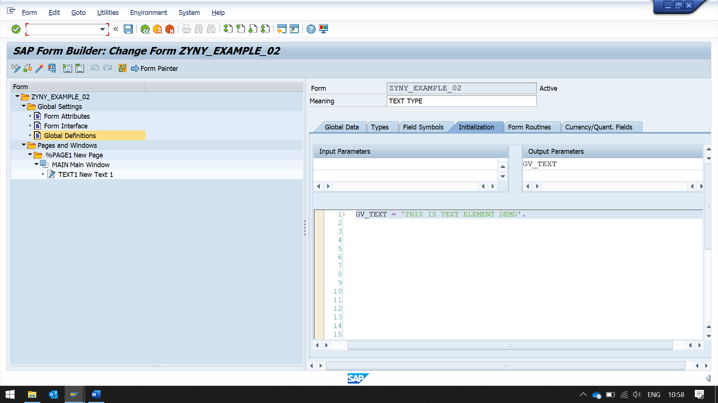 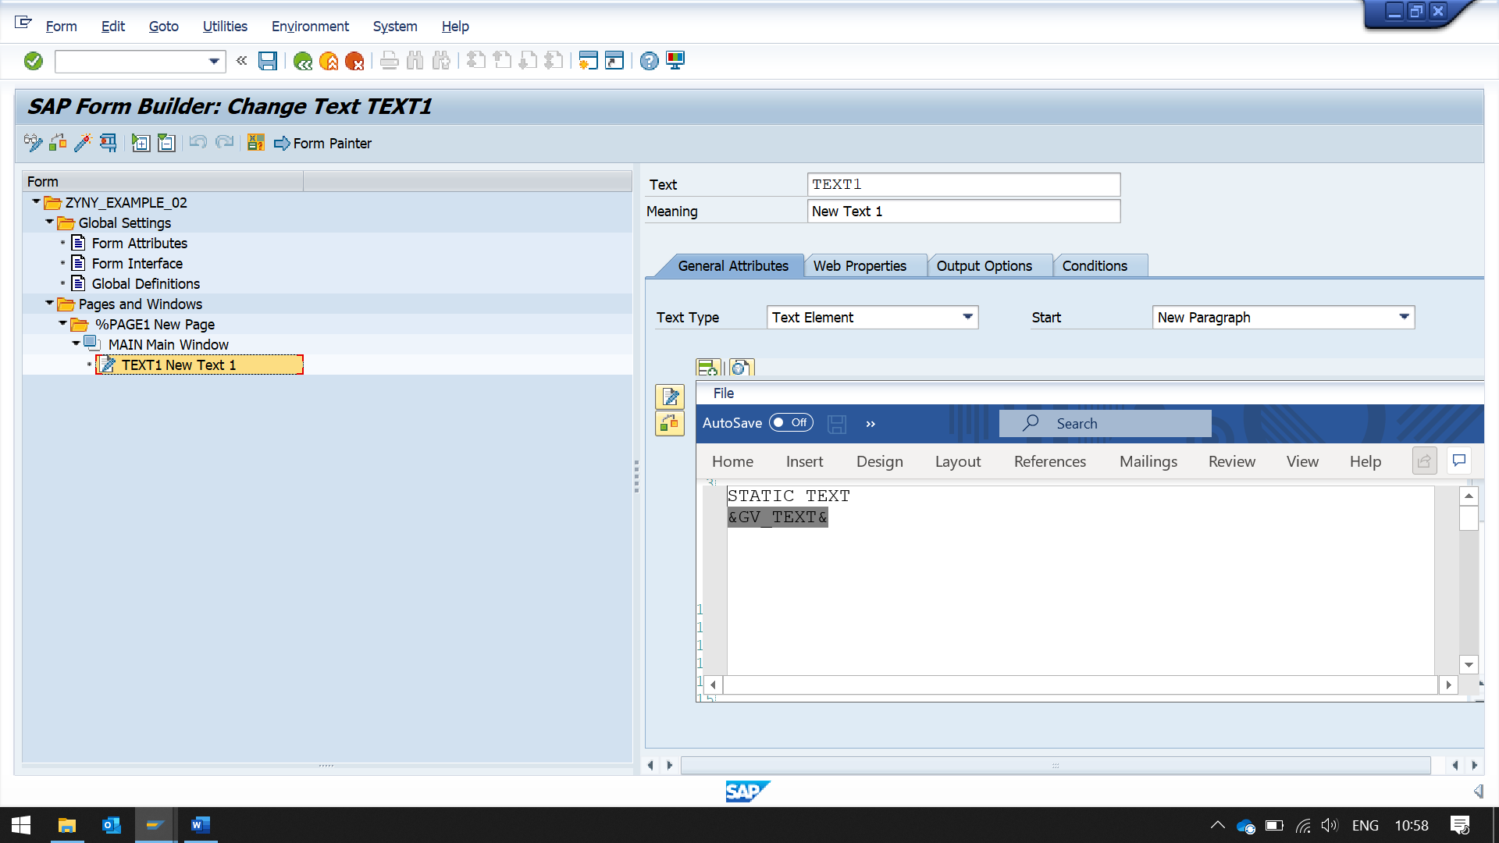

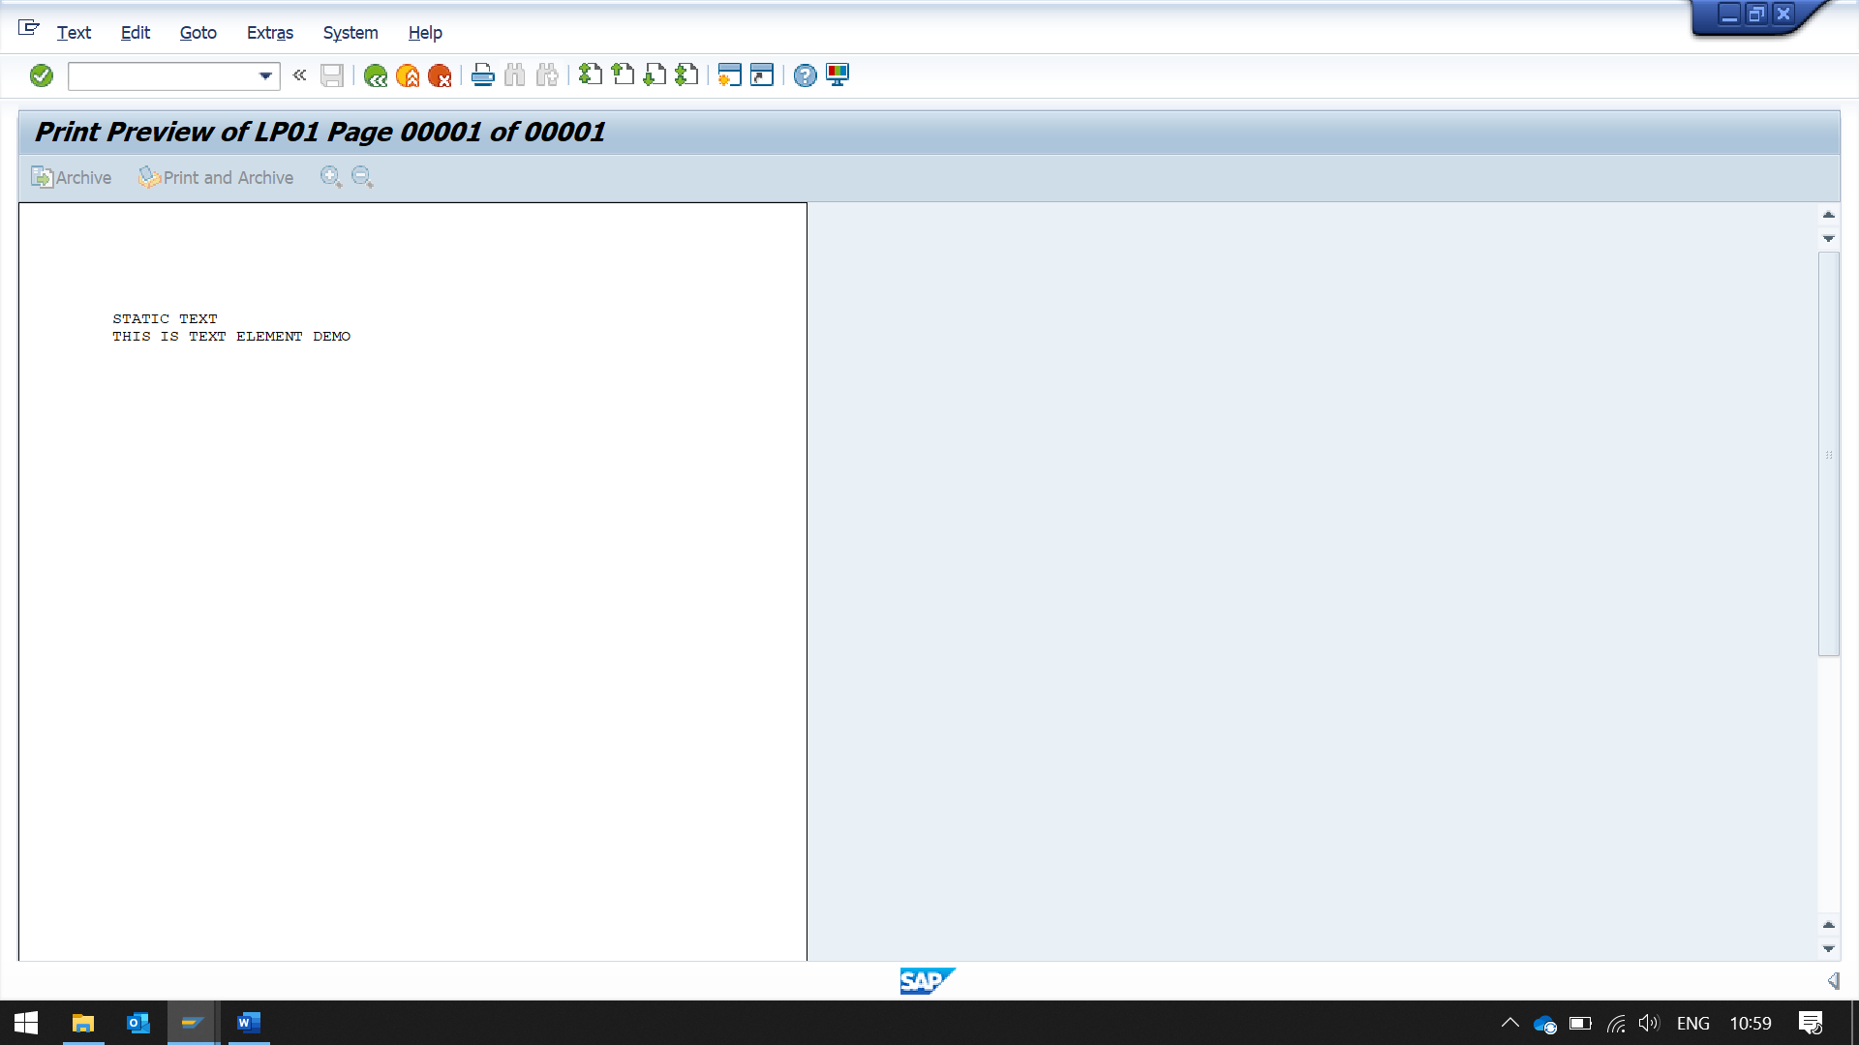

WE CAN INSERT FIELD, USING BUTTON INSERT FIELD

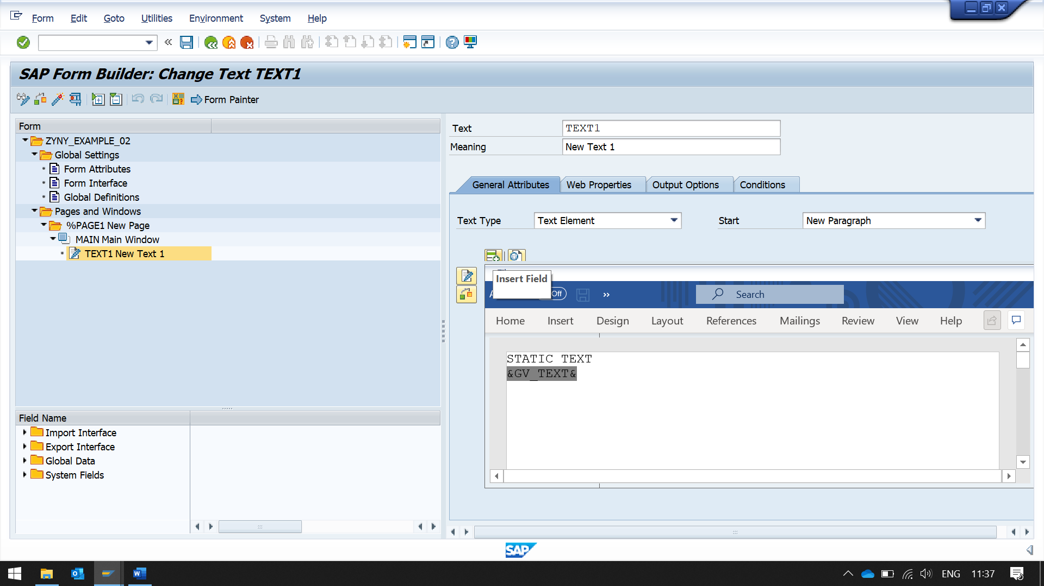 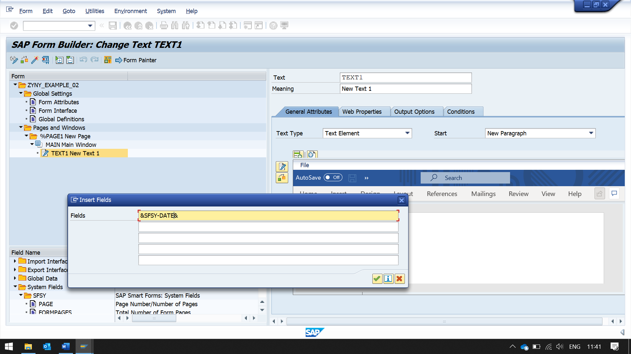 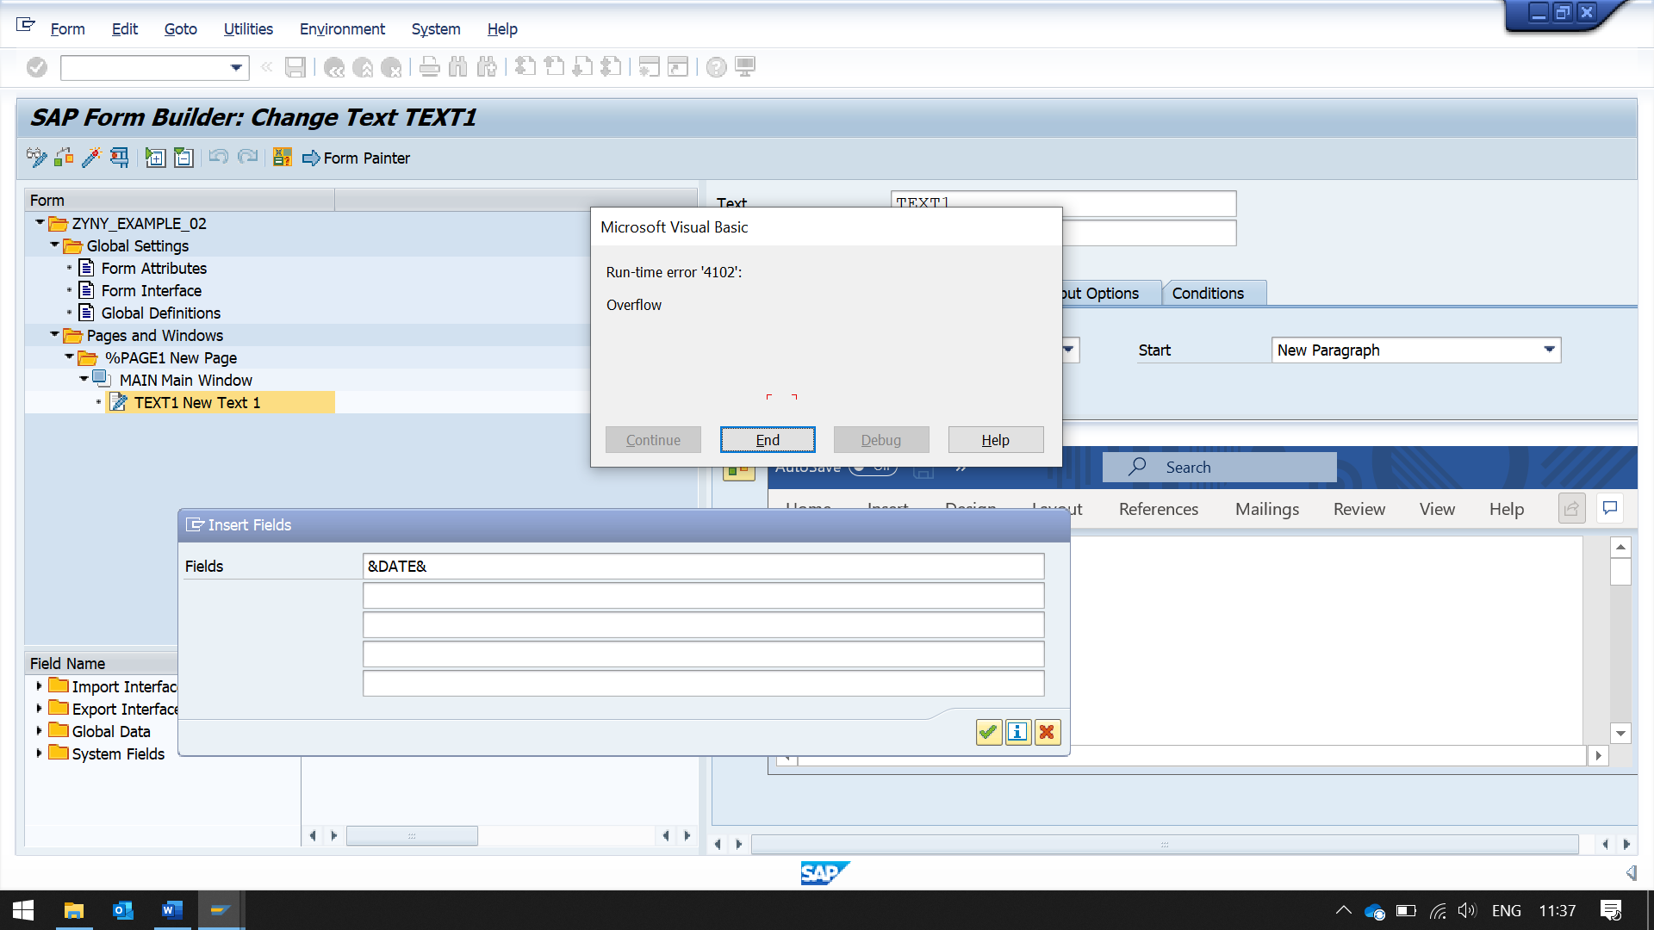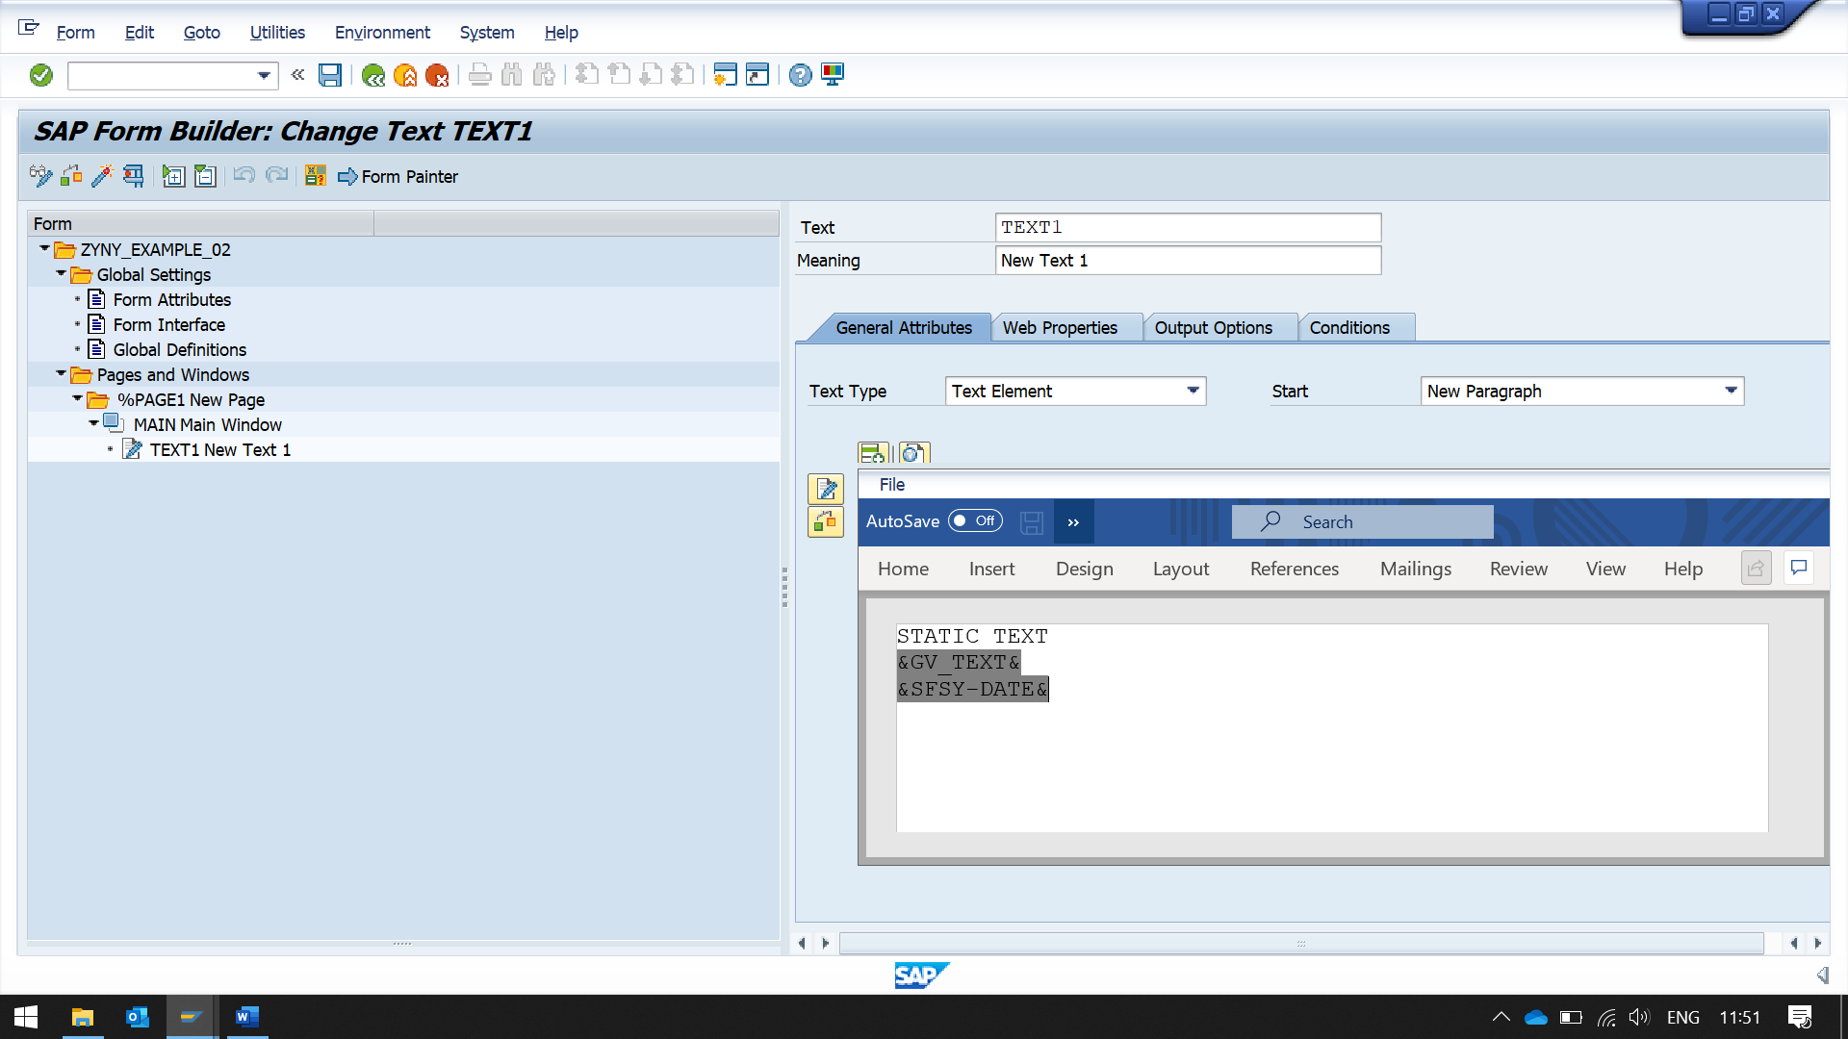 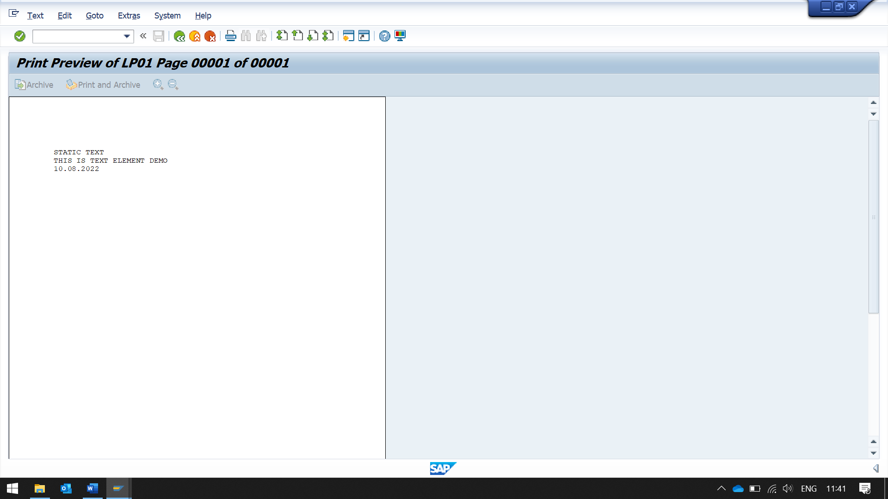

FOR DISPLAYING LONG TEXT

CAN USE TEXT ELEMENT, BUT SHOULD USE INCLUDE TEXT

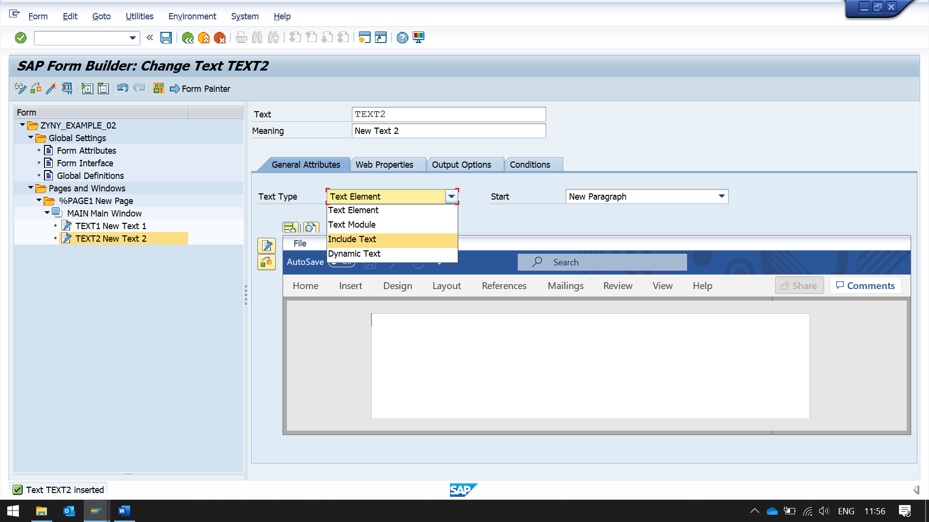

--------------------------------------------------------------------------------------------------------------------------------------

NOT WORKING

--------------------------------------------------------------------------------------------------------------------------------------

T CODE - SO10

TO CREATE STANDARD TEXT OBJECT

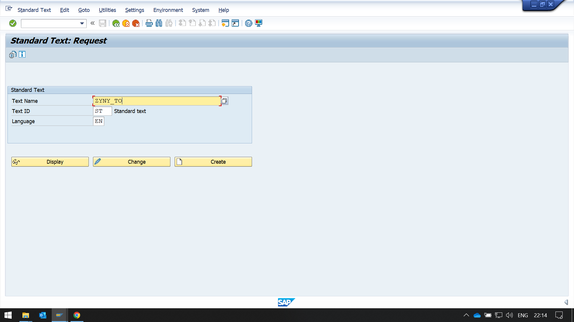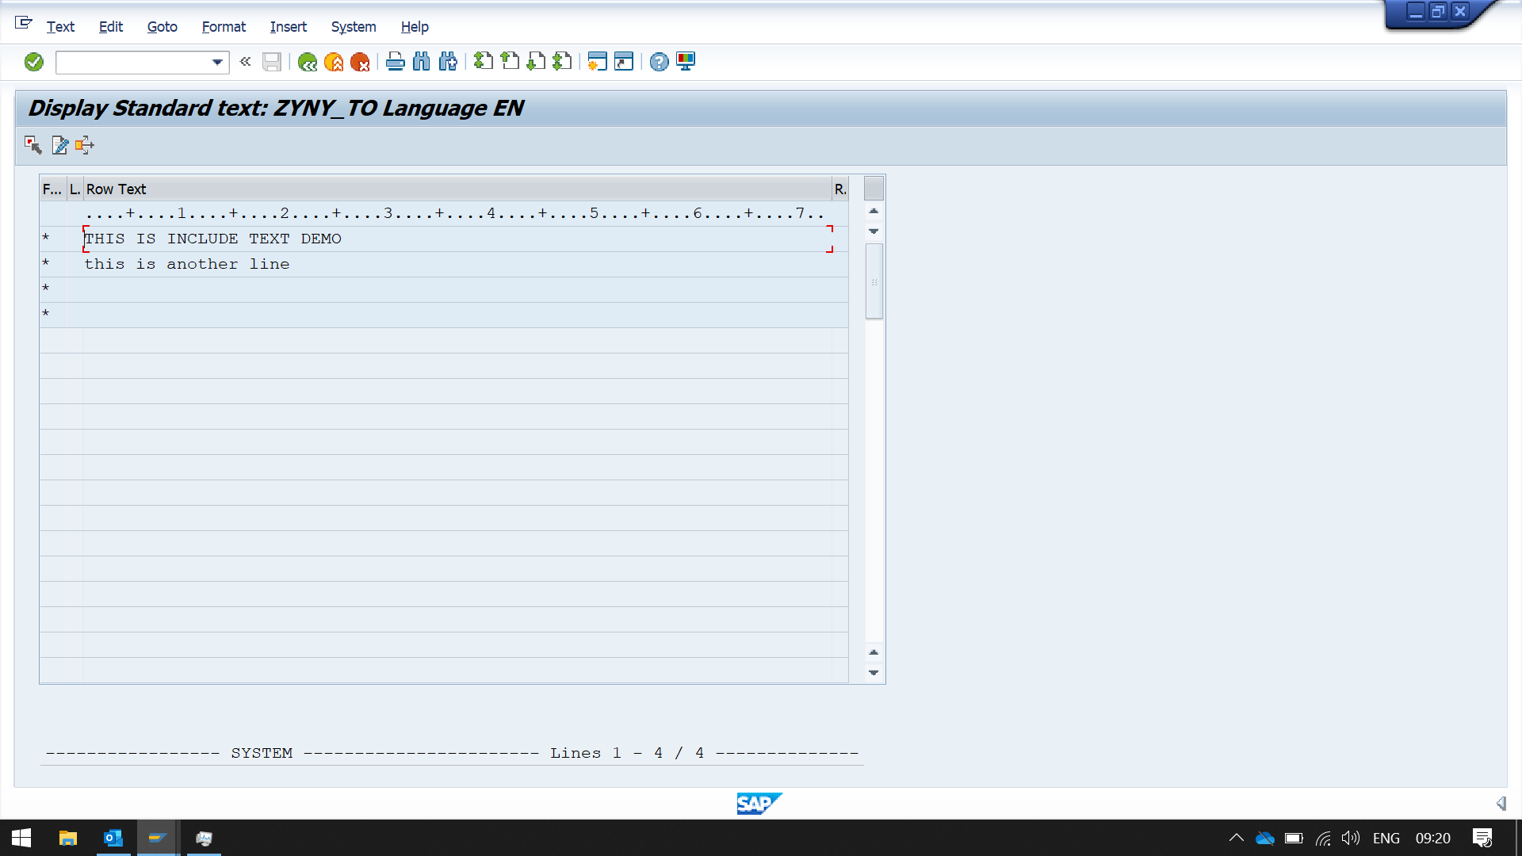

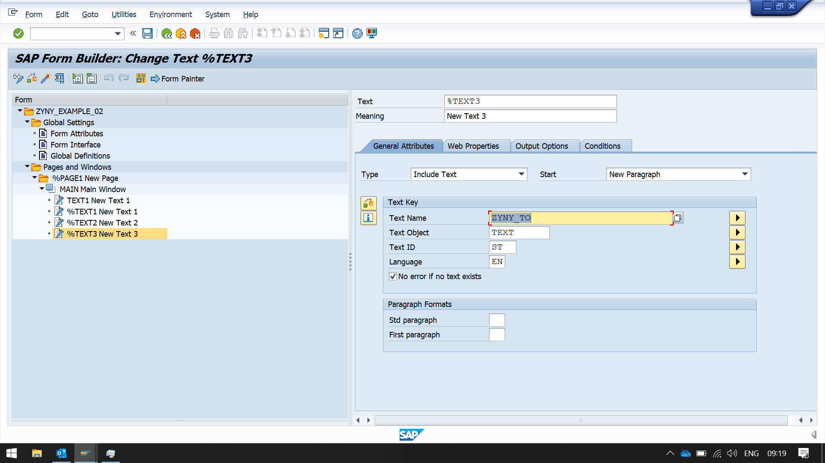

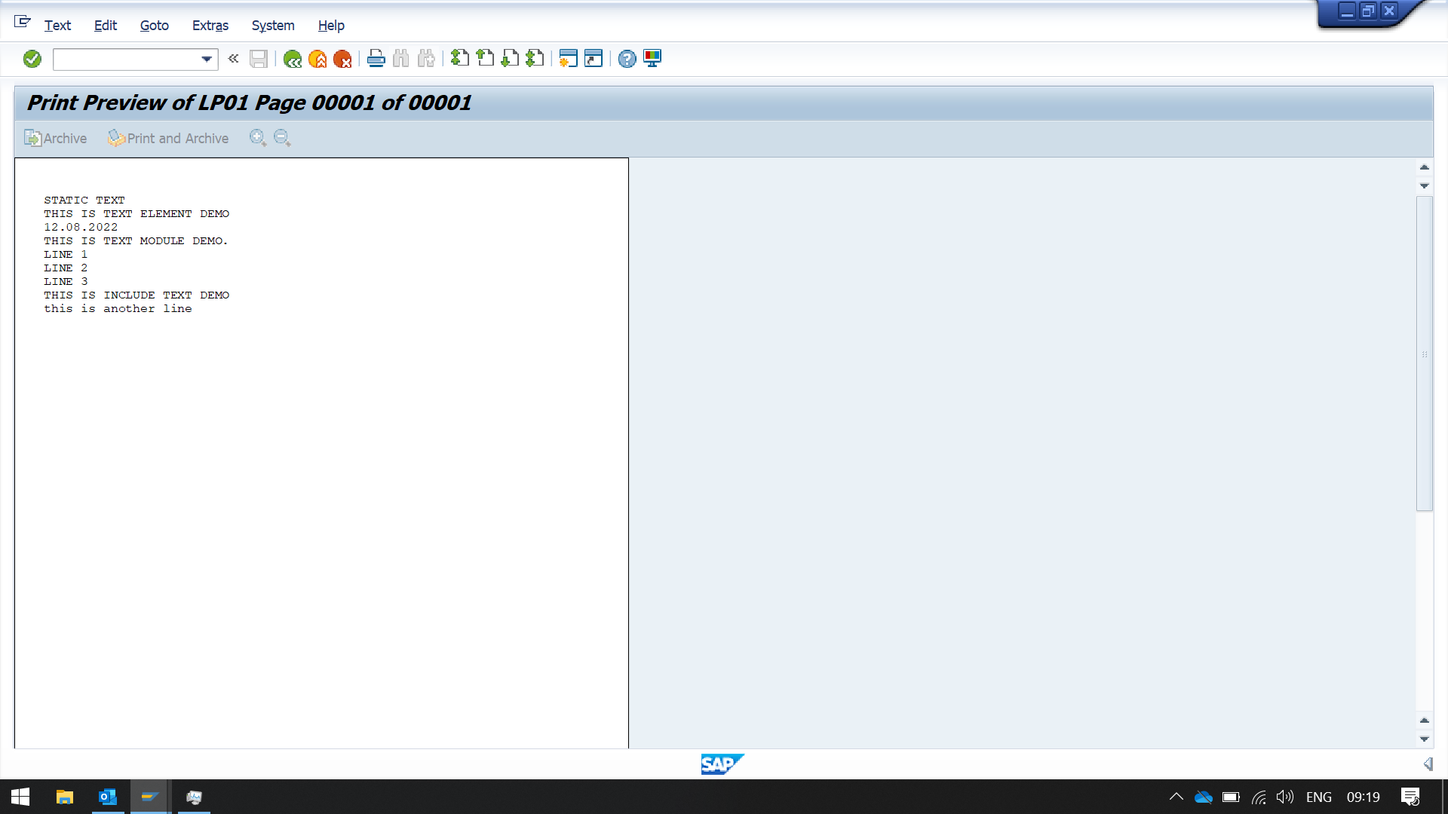

T CODE - SMARTFORMS

TEXT MODULE

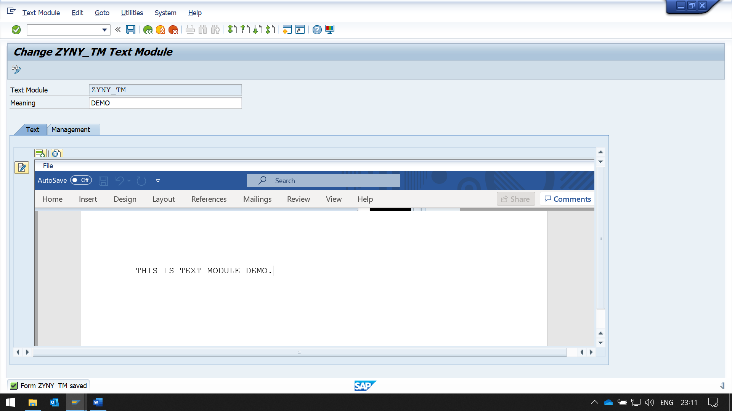

GO TO SAMRTFORM

CREATE A NEW TEXT IN MAIN WINDOW, THEN CHNAGE THE TEXT TYPE TO TEXT MODULE

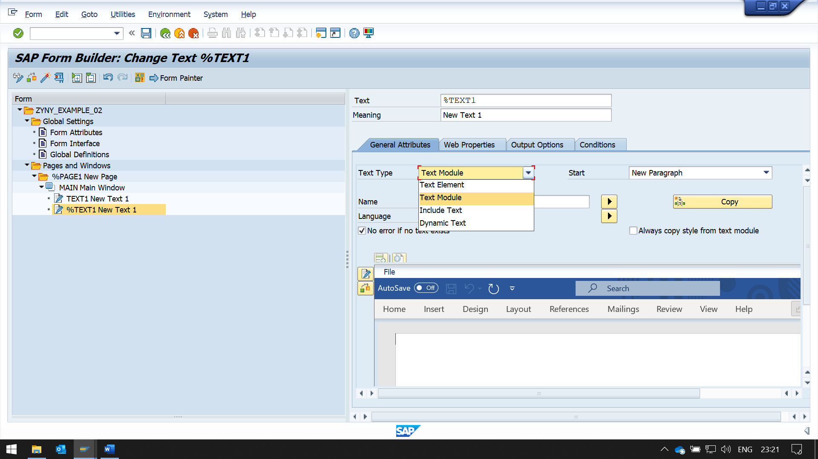

PASS NAME AND LANGUAGE IN THE FIELD

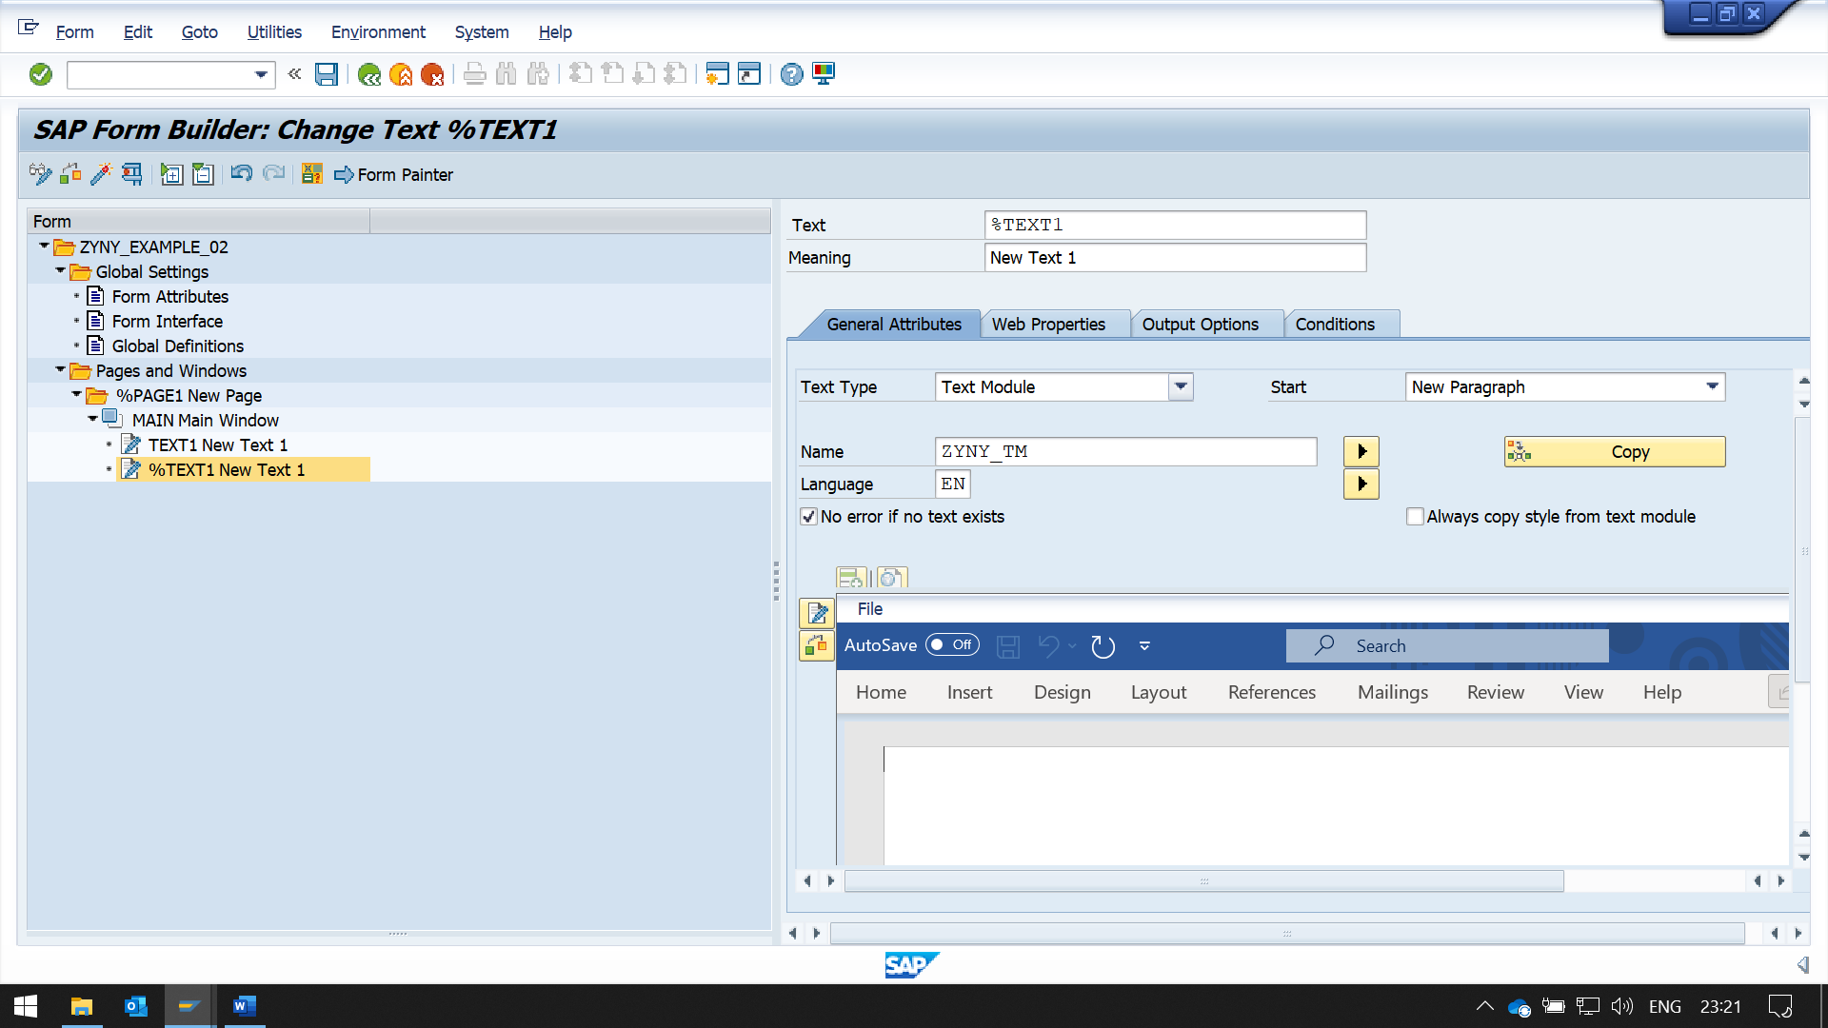

SAVE AND ACTIVATE , THEN EXECUTE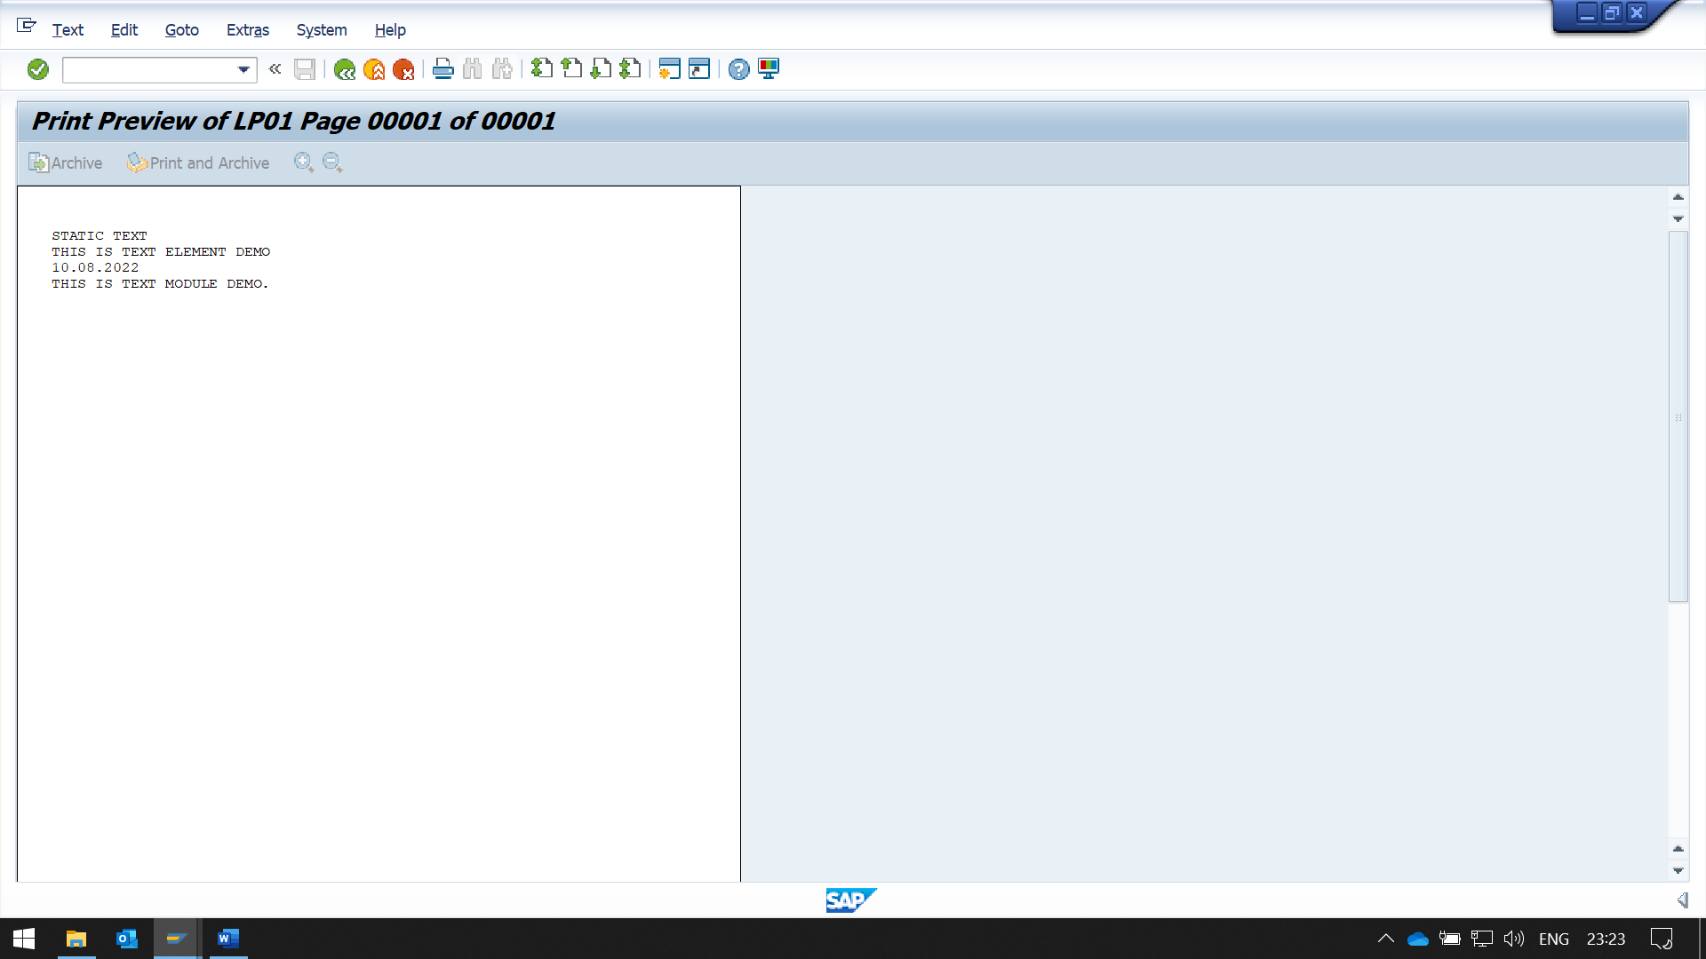

DYNAMIC TEXT IN TEXT

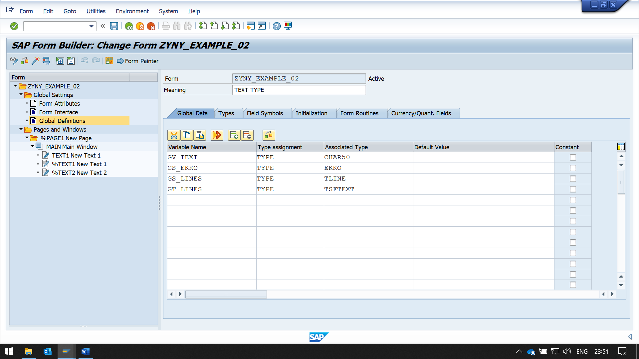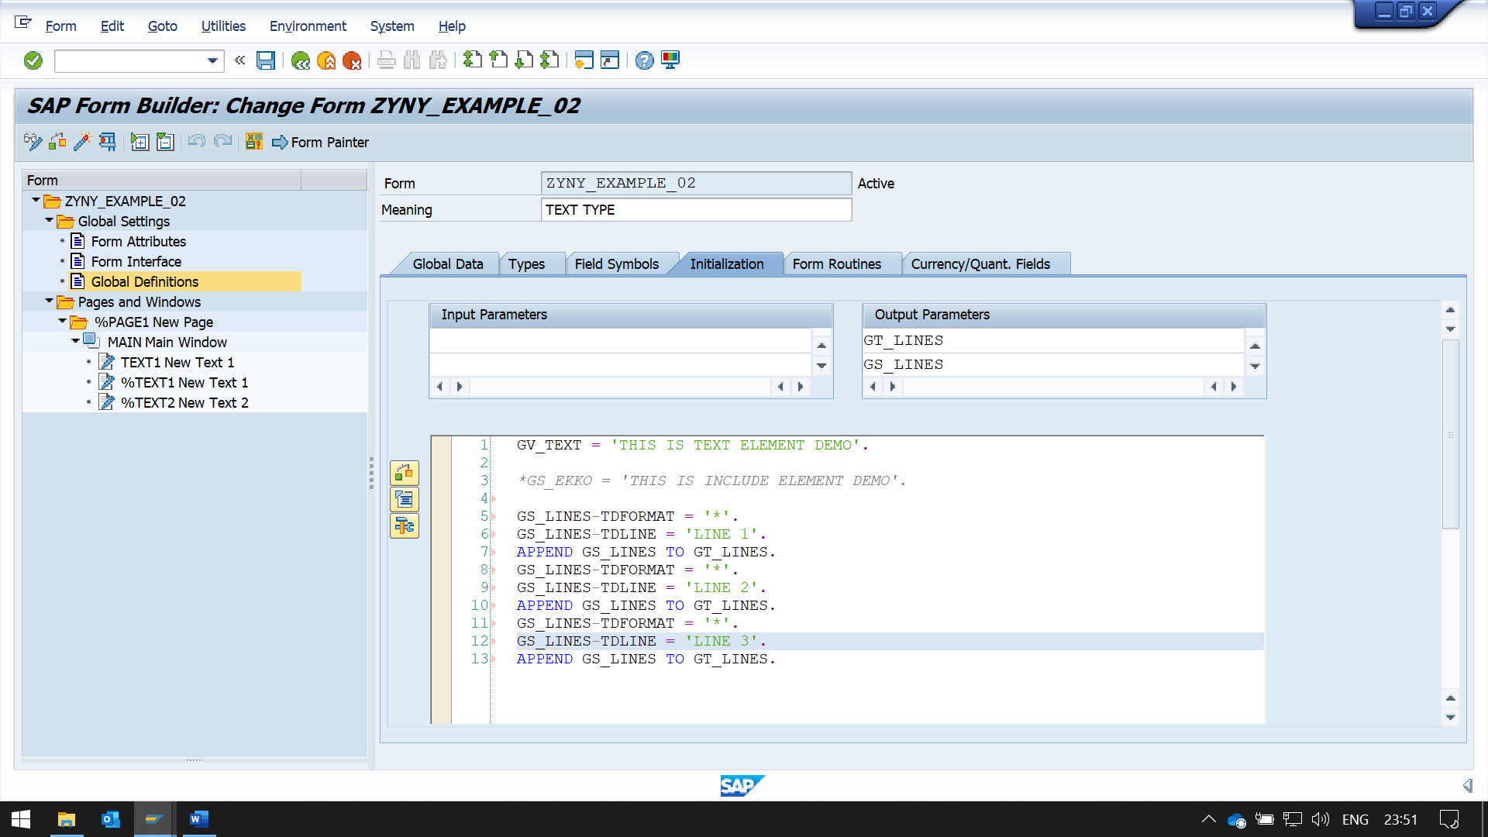

GO TO FORMS, CREATE A TEXT , THEN CHANGE THE TEXT TYPE TO DYNAMIC TEXT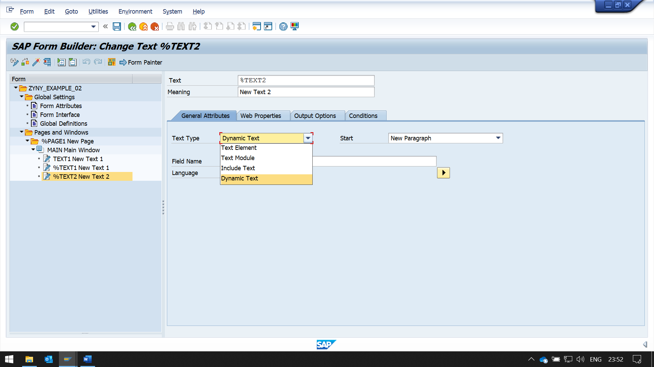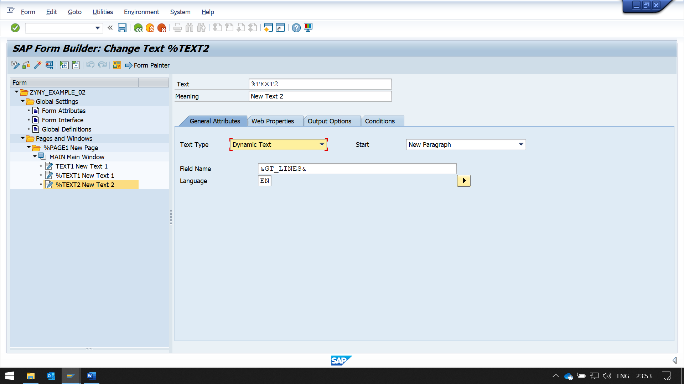

NOW ENTER THE FIELD NAME IN THE BLANK FIELD

